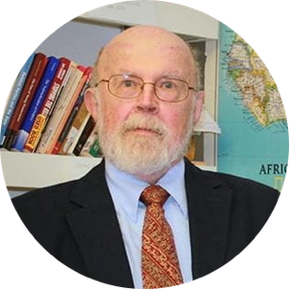 | 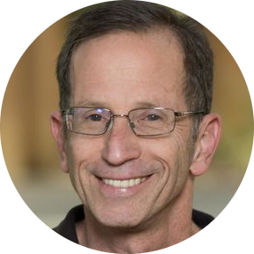 | 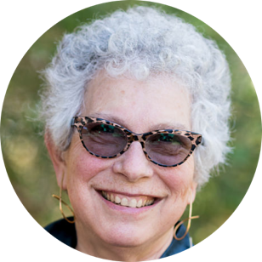 | 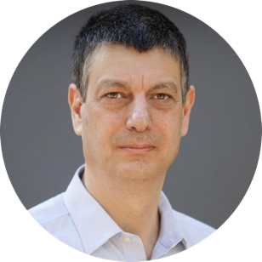 | 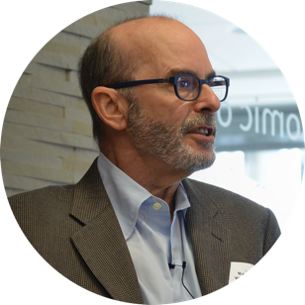
Robert Bates  (Harvard) | Avner Grief  (Stanford) | Margaret Levi  (Stanford) | Jean-Laurent Rosenthal  (Caltech) | Barry Weingast  (Stanford)

